Autism Awareness Month
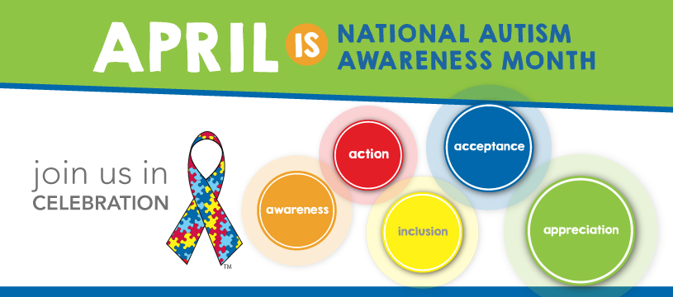
During Autism Awareness Month in April, Autism NI run a number of awareness campaigns to grow knowledge and understanding of Autism throughout Northern Ireland. Due to the increase of diagnosis figures, this is an important exercise Autism NI carries out every year. Here are some of the ways you can get involved this year!
For more information visit:
http://www.autismni.org/world-autism-awareness-month-.html

