Northern Integrated Care Partnerships
Call for Expressions of Interest from Service Users and Carers
There are currently vacancies for service users and carer members on the following ICP Partnership Committees in the Northern area:

Antrim/Ballymena ICP – Service User Rep and Carer Rep
Causeway ICP – Carer Rep
Mid-Ulster ICP – Carer Rep

Visit the website at the link below for the most up to date information on vacancies.
http://www.hscboard.hscni.net/icps/about-icps/how-can-you-get-involved/

What are Integrated Care Partnerships?

Integrated Care Partnerships are networks of health and social care providers. Seventeen have been set up across Northern Ireland.

Each Partnership Committee has about thirteen members and brings together, doctors, nurses, pharmacists, social workers, hospital specialists, other healthcare professionals, service users and carers as well as the voluntary and community sector and representatives from local councils.

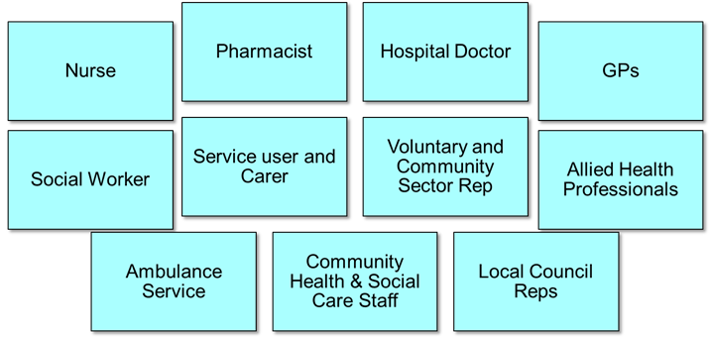
What do Integrated Care Partnerships do?
Each Integrated Care Partnership is charged with improving services for their locality, looking at how care is delivered from prevention through to end of life. They will then make changes so that services are joined up and are delivering the right care, in the right place at the right time.
They currently focus on specific service areas:

- Services for the Frail Elderly (incl Care Homes and Dementia)
- Stroke services (incl Prevention)
- Respiratory services
- Diabetes services
- Palliative and End of Life Care
- Social Prescribing

How does each Integrated Care Partnership work?
Each Partnership committee carries out its work through meeting at least four times per year, though currently are meeting via Zoom Technology, to discuss,agree and implement changes that are needed in its locality.

What is the role of the service user and carer?
Service users and carers with experience of any of the key clinical service areas and an interest in improving services in their locality are invited to get involved.
Service users or carers who get involved will be asked to:
- Attend all meetings in their locality
- Share their experiences as a service user or carer of health and social care services in your area
- Make recommendations and get involved in service improvements that will affect them
- Work closely with doctors, nurses, pharmacists, social workers and others to develop more joined up ways of working

How will service users and carers be supported in their role?

- A small business support team is available in each locality to support the work of Integrated Care Partnerships and that team will help service users and carers in their role on the committee.

- An information and discussion session will be held for service users or carers appointed to sit on Partnership Committees so that they can ask questions, prepare for their role and highlight any support they may need.

- Costs that service users or carers incur in their work with Integrated Care Partnerships will be paid back eg; travel, respite care or personal support.

- The Chairperson of your Partnerships Committee person will meet with you prior to and after each group meeting as needed to clarify any issues and answer any queries.
To find out more please visit the ICP pages on the Health and Social Care Boards website at the link below.
http://www.hscboard.hscni.net/icps/more-about-icps/user-carer-vacancies/
Here you can view a short video clip outlining what ICPs are about, read frequently asked questions about ICPs and read what Johnny the carer representative for Lisburn ICP has to say.
For further information and to get involved contact: Anne Marie O’Boyle, Northern ICP Business Manager,
telephone: 07792 927695;
email: Anne-Marie.OBoyle@hscni.net

